[GOOGLE EARTH ENGINE](EE01%20Earth%20Engine%20(EE).docx) [APPLICATION PROGRAMMING INTERFACE](EE05%20%20%20The%20EE%20API.docx) [CAPABILITIES](EE07%20%20%20%20%20%20API%20Capabilities.docx)

PROCESSING **LAYER** [WIDGETS](EE08%20%20%20%20%20%20%20%20%20Widgets.docx)

A layer is an EE widget object that represents the cartographic depictions of an individual dataset in a map. Layers can be processed by using operations

of the types listed below, which vary according to the nature of that processing. Each operation name is linked to a separate page describing that operation.

**DOCUMENTING** LAYERS ee.data.getThumbId ee.data.getTileBaseUrl ee.data.getTileUrl ee.data.MakeThumbUrl

**PRESENTING** LAYERS Map.addLayer Map.centerObject

[GOOGLE EARTH ENGINE](EE01%20Earth%20Engine%20(EE).docx) [APPLICATION PROGRAMMING INTERFACE](EE05%20%20%20The%20EE%20API.docx) [CAPABILITIES](EE07%20%20%20%20%20%20API%20Capabilities.docx)

**DOCUMENTING** LAYER [WIDGETS](EE08%20%20%20%20%20%20%20%20%20Widgets.docx)

ee.data.getThumbId reports the Thumbnail ID and token associated with a specified dataset.

newThumbID = ee.data.getThumbId ( settings)

A dictionary of strings associated with two keys: “mapid” and “token”

Instructions identifying data and data-display options in the same manner as **Map.addlayer** settings but with the following additional settings

**'id' :** **X** gives **X** as the asset ID for the dataset to be specified, given as a string.

**'scale' :** **#, ##** gives **#** as the width and ## as the height (in pixels) of the thumbnail, given as numbers

**'region' :** **ESWN** gives **ESWN** as a quoted list of four lists, each containing the longitude and latitude

coordinate numbers of a corner point of the region to be depicted in the thumbnail.

**'crs' :** **X** gives **X** as the coordinate system to be employed, given as a string.

var TheTHUMBID = ee.data.getThumbId( {'id':'srtm90_v4', min:0, max:700,

palette:'001100,009900', 'scale':30, 'crs':'EPSG:4326',

'region':'[[-80,42],[-75,42],[-75,43], [-80,43]]' } );

print( TheTHUMBID );

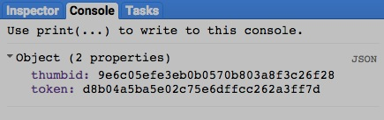

[GOOGLE EARTH ENGINE](EE01%20Earth%20Engine%20(EE).docx) [APPLICATION PROGRAMMING INTERFACE](EE05%20%20%20The%20EE%20API.docx) [CAPABILITIES](EE07%20%20%20%20%20%20API%20Capabilities.docx)

**DOCUMENTING** LAYER [WIDGETS](EE08%20%20%20%20%20%20%20%20%20Widgets.docx)

ee.data.getTileBaseUrl reports the web address (URL) used by Earth Engine to manage tiles which is normally “https://earthengine.googleapis.com.”

newURL = ee.data.getTileBaseUrl( )

A new string set to the web address

var TheURL = ee.data.getTileBaseUrl( );

print( TheURL );

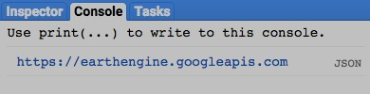

[GOOGLE EARTH ENGINE](EE01%20Earth%20Engine%20(EE).docx) [APPLICATION PROGRAMMING INTERFACE](EE05%20%20%20The%20EE%20API.docx) [CAPABILITIES](EE07%20%20%20%20%20%20API%20Capabilities.docx)

**DOCUMENTING** LAYER [WIDGETS](EE08%20%20%20%20%20%20%20%20%20Widgets.docx)

ee.data.getTileUrl reports the web address (URL) for a tile specified by Map ID, longitude, latitude, and zoom level.

newURL = ee.data.getTileUrl ( mapID, longitude, latitude, zoomLevel)

The specified level of detail, given as a number ranging from 1 (coarsest) to 20 (finest)

The specified map ID

A new string set to the web address

The specified longitude, given as a number referring to degrees

The specified latitude, given as a number referring to degrees

var TheMAPID = ee.data.getMapId( {'id':'srtm90_v4', min:0, max:700, palette:'001100,009900'} );

var TheURL = ee.data.getTileUrl( TheMAPID, -76.5308, 41.9922, 9 );

print( TheURL );

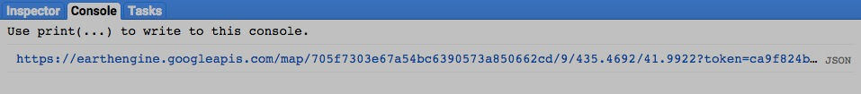

[GOOGLE EARTH ENGINE](EE01%20Earth%20Engine%20(EE).docx) [APPLICATION PROGRAMMING INTERFACE](EE05%20%20%20The%20EE%20API.docx) [CAPABILITIES](EE07%20%20%20%20%20%20API%20Capabilities.docx)

**DOCUMENTING** LAYER [WIDGETS](EE08%20%20%20%20%20%20%20%20%20Widgets.docx)

ee.data.makeThumbUrl reports the web address (URL) for a specified thumbnail ID.

newURL = ee.data.makeThumbUrl ( oldThumbID)

A new string set to the web address

The thumbnail ID as generated by **ee.data.getThumbId**

var TheTHUMBID = ee.data.getThumbId( {'id':'srtm90_v4', min:0, max:700,

palette:'001100,009900', 'scale':30, 'crs':'EPSG:4326',

'region':'[[-80,42],[-75,42],[-75,43], [-80,43]]' } );

var TheURL = ee.data.makeDownloadUrl( TheTHUMBID );

print( TheURL );

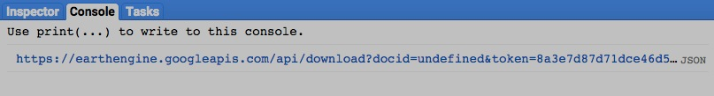

[GOOGLE EARTH ENGINE](EE01%20Earth%20Engine%20(EE).docx) [APPLICATION PROGRAMMING INTERFACE](EE05%20%20%20The%20EE%20API.docx) [CAPABILITIES](EE07%20%20%20%20%20%20API%20Capabilities.docx)

**PRESENTING** LAYER [WIDGETS](EE08%20%20%20%20%20%20%20%20%20Widgets.docx)

Map.addLayer adds a specified geometry, feature, feature collection, image, or image collection to the map as a layer.

Map.addLayer ( dataset*,  settings, name, visibility* )

Display settings. These described elsewhere in reference to the mapping of geometries, features, feature collections, images, or image collections

The specified image, image collection, feature, or feature collection

A Boolean set to true (only) if the layer being displayed should initially be toggled on (visible) rather than off (invisible).Visibility can also be adjusted interactively by using the map’s layer listing.

The name for the layer to be displayed, given as a string. This name will appear on the map’s layer list listing.Default: "Layer N," where N is 1, 2, 3, and so on according to the order in which layers are added to the display.

var TheFEATURES = ee.FeatureCollection('ft:1fRY18cjsHzDgGiJiS2nnpUU3v9JPDc2HNaR7Xk8'); // U.S. States

Map.addLayer ( TheFEATURES );

Map.addLayer ( TheFEATURES, {color:'996644'} );

Map.addLayer ( TheFEATURES, {color:'aa7755'}, 'Recolored' );

Map.addLayer ( TheFEATURES, {color:'bb8866'}, 'Hidden', false );

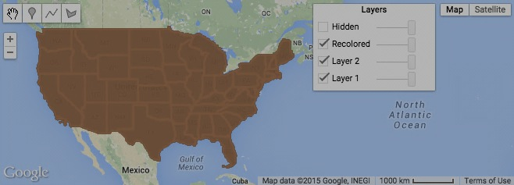

[GOOGLE EARTH ENGINE](EE01%20Earth%20Engine%20(EE).docx) [APPLICATION PROGRAMMING INTERFACE](EE05%20%20%20The%20EE%20API.docx) [CAPABILITIES](EE07%20%20%20%20%20%20API%20Capabilities.docx)

**PRESENTING** LAYER [WIDGETS](EE08%20%20%20%20%20%20%20%20%20Widgets.docx)

Map.centerObject pans the map to center on a specified layer at a specified level of detail.

Map.centerObject ( theLayer, *zoomLevel* )

The specified level of detail, given as a number ranging from 1 (global) to 20 (local)

The specified LAYER, given as the name

or asset ID of an image, image collection,

feature, Feature collection, or geometry

var TheLAYER = ee.Image( 'LM40630461989181AAA03' );

Map.centerObject( TheLAYER, 8 );

Map.addLayer( TheLAYER );

